Homework

**Question:**

Use predicates (1) through (10) to answer the following questions.

6. *p* = *a* ↔ (*b* ∧ *c*)

7. *p* = (*a* ∨ *b*) ∧ (*c* ∨ *d*)

(e) Identify all pairs of rows from your table that satisfy correlated active clause coverage (CACC) with respect to each clause.

(f) Identify all pairs of rows from your table that satisfy restricted active clause coverage (RACC) with respect to each clause.

Answer:

(e).

|  |  |  |  |  |
| --- | --- | --- | --- | --- |
|  | a | b | c | *a* ↔ (*b* ∧ *c*) |
| 1 | T | T | T | T |
| 2 | T | T | F | F |
| 3 | T | F | T | F |
| 4 | T | F | F | F |
| 5 | F | T | T | F |
| 6 | F | T | F | T |
| 7 | F | F | T | T |
| 8 | F | F | F | T |

For clause a:

So we can see only **one** pair (**1**,**5)** can satisfy **CACC**.

And **RACC** can only be satisfied by **one** pair (**1**,**5)**.

For clause b:

CACC can be satisfied by choosing any of rows **1,6** AND rows **3** -----total **2** pairs, that is **(1,3) ,(6,3)**

**RACC** can be satisfied by row pair (**1,3**)

For clause c:

CACC can be satisfied by rows **1,7** AND **2** which has two pairs: **(1,2),(7,2)**

RACC can be satisfied by only one pair that is pair **(1,2)**

(f).

|  |  |  |  |  |  |
| --- | --- | --- | --- | --- | --- |
|  | a | b | c | d | (*a* ∨ *b*) ∧ (*c* ∨ *d*) |
| 1 | T | T | T | T | T |
| 2 | T | T | T | F | T |
| 3 | T | T | F | T | T |
| 4 | T | T | F | F | F |
| 5 | T | F | T | T | T |
| 6 | T | F | T | F | T |
| 7 | T | F | F | T | T |
| 8 | T | F | F | F | F |
| 9 | F | T | T | T | T |
| 10 | F | T | T | F | T |
| 11 | F | T | F | T | T |
| 12 | F | T | F | F | F |
| 13 | F | F | T | T | F |
| 14 | F | F | T | F | F |
| 15 | F | F | F | T | F |
| 16 | F | F | F | F | F |

For clause a:

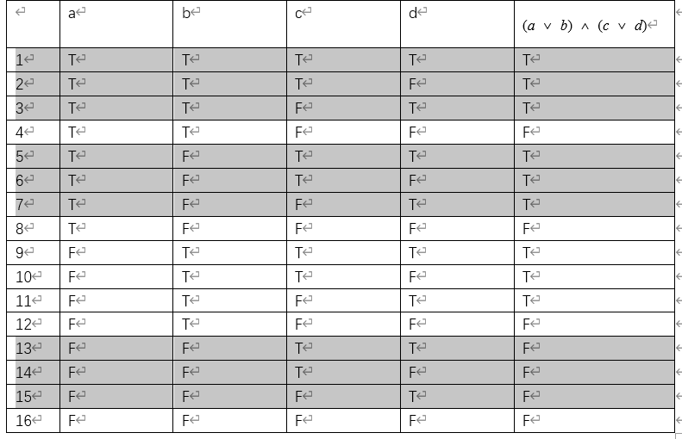

CACC satisfied any of **1,2,3,5,6,7** AND **13,14,15** as pairs, that total **18** pairs

RACC satisfied by pairs **(1,13),(2,14),(3,15),(5,13),(6,14),(7,15)------total 6 pairs**

For clause b.

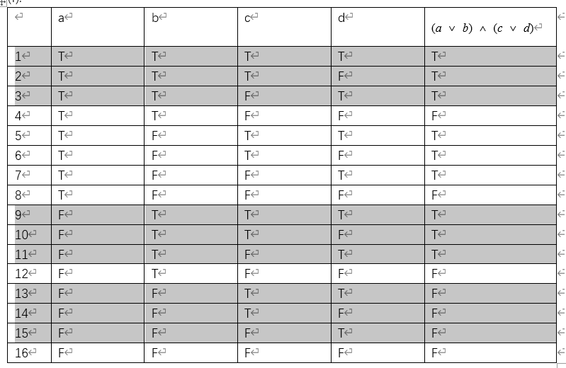

CACC satisfied by any of pairs **1,2,3,9,10,11 AND 13,14,15** ----------total **18** pairs.

RACC satisfied by pairs **(1,13),(2,14),(3,15),(9,13),(10,14),(11,15)**

For clause c.

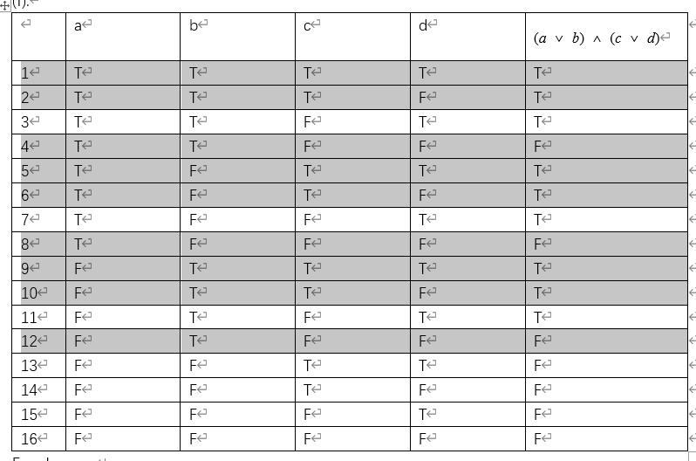

CACC satisfied by any of pairs **1,2,5,6,9,10 AND 4,8,12**--------total **18** pairs.

RACC satisfied by pairs **(1,4),(2,4) ,(5,8) ,(6,8) ,(9,12) ,(10,12)**

For clause d.

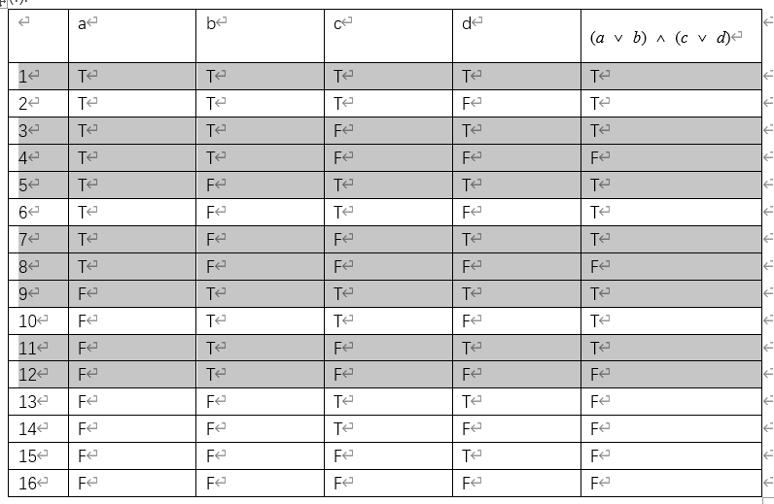

CACC satisfied by any of pairs **1,3,5,7,9,11 AND 4,8,12**--------total **18** pairs.

RACC satisfied by pairs **(1,4),(3,4) ,(5,8) ,7,8) ,(9,12) ,(11,12)**